MACH4METAL

Metalworking machinery
Transito 21,
6909 DA BABBERICH, Netherlands
Tel. + 31 (0)316 – 247123
Fax. + 31 (0)316 - 247956
info@mach4metal.com
www.mach4metal.com

Account No: 66.52.13.883
IBAN : NL33 INGB 0665 2138 83
BIC : INGBNL2A

SCHIESS 20 DKE 180 vertical borer

- Make : SCHIESS Germany
- Type : 20 DKE 180
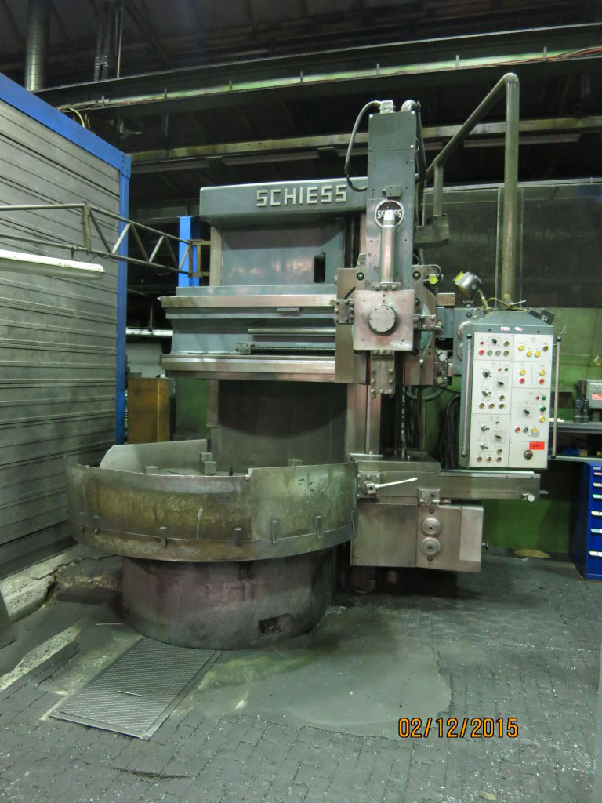
- Mach.No. : 37 88-04
- YOP :

- Table size Ø : 1.800
- Swing max Ø : 2.000
- Swing max Ø side head : 1.900

- Turning height under tool : 1.000
- Vertical travel ram : 700
- Vertical travel cross rail : 1.400

- Torq on chuck : 2.600
- Work load : 12.000

- Speeds range : 2.5 – 200 Rpm
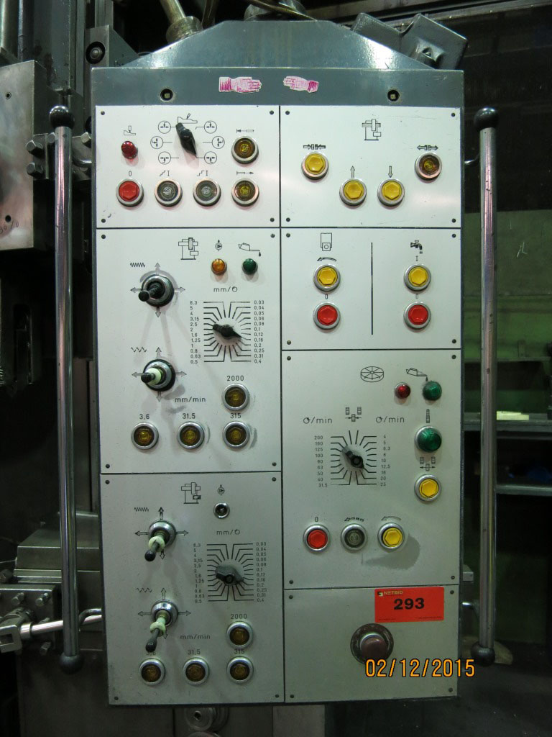
- Vario feeds :

- Dimensions

- Length : 4.500
- Width : 4.000
- Height : 4.000
- Weight : 22 Ton
- Power : 55 KW

- Incl. side support
- Incl. 4 heavy jaws

Please Note: The above information has been obtained to the best of our ability and belief from, and from the manufacturers where possible. It is given in good faith, but its accuracy can not be guaranteed. Accordingly, it will not form a representation or constitute contractual terms. We advise you to check any vital details!

